Annotation with Bounding Boxes

Original Image

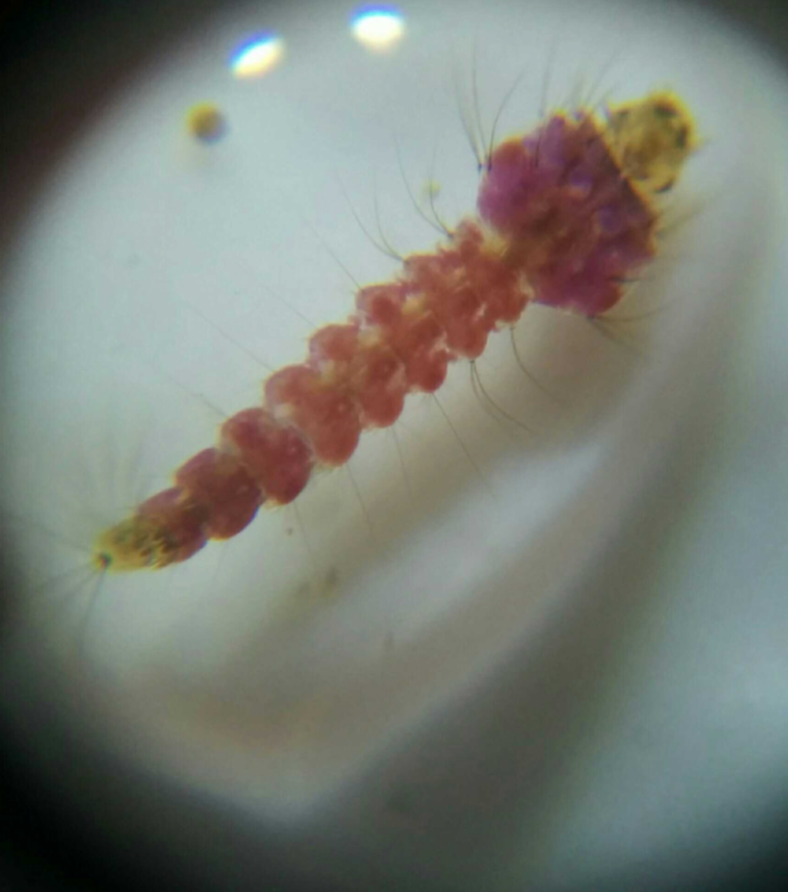

Without hairs (Thorax & Abdomen) With all Hair components

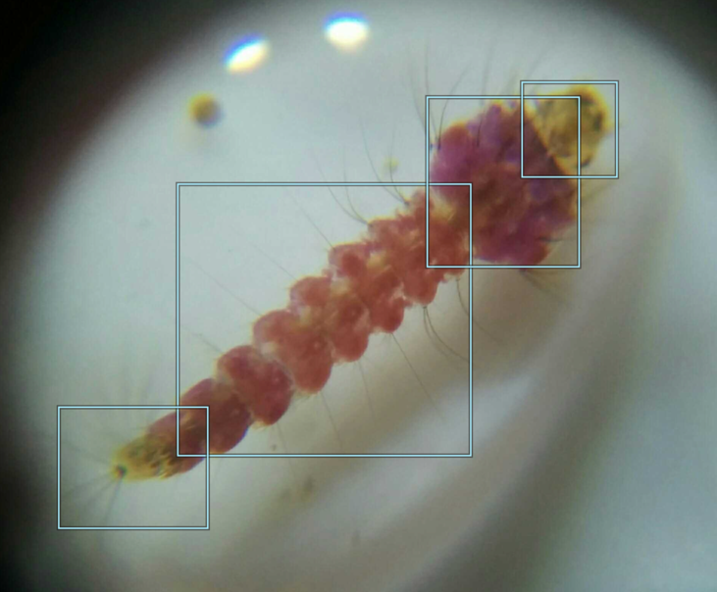 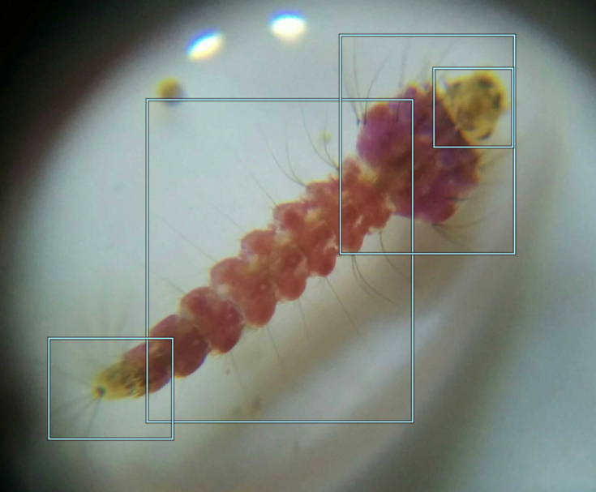

Original Image

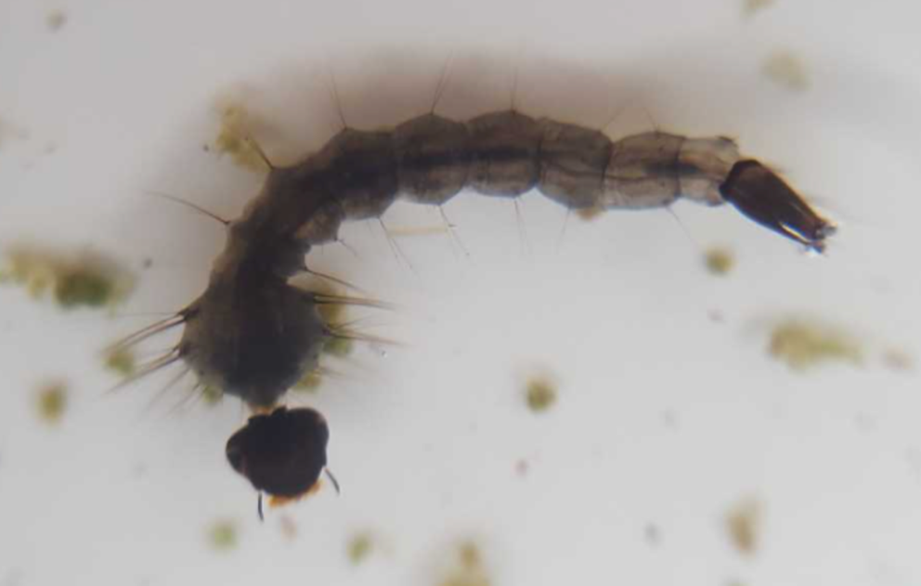

Without hairs (Thorax & Abdomen) With all Hair components

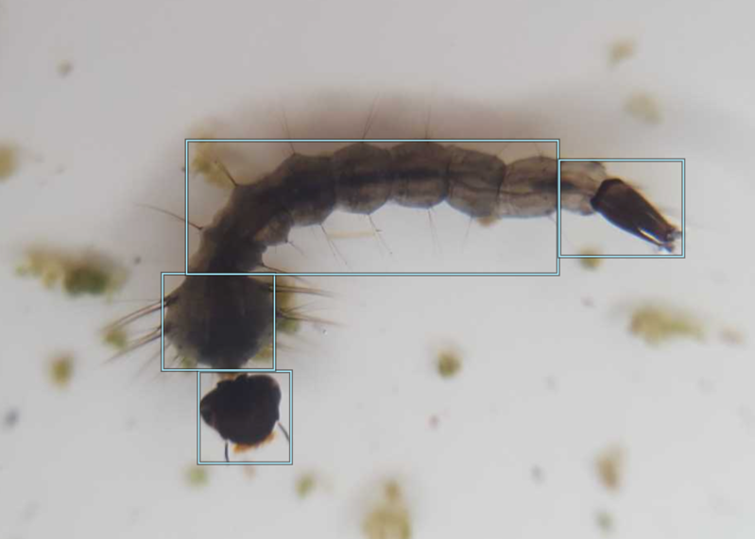 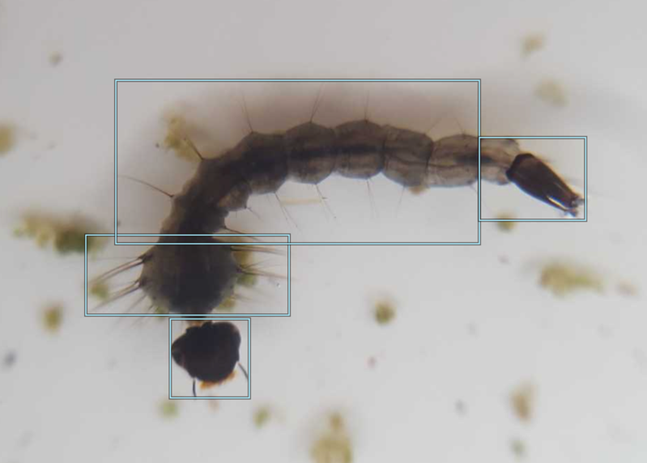

Challenging Examples

Original Image Suggested boxes

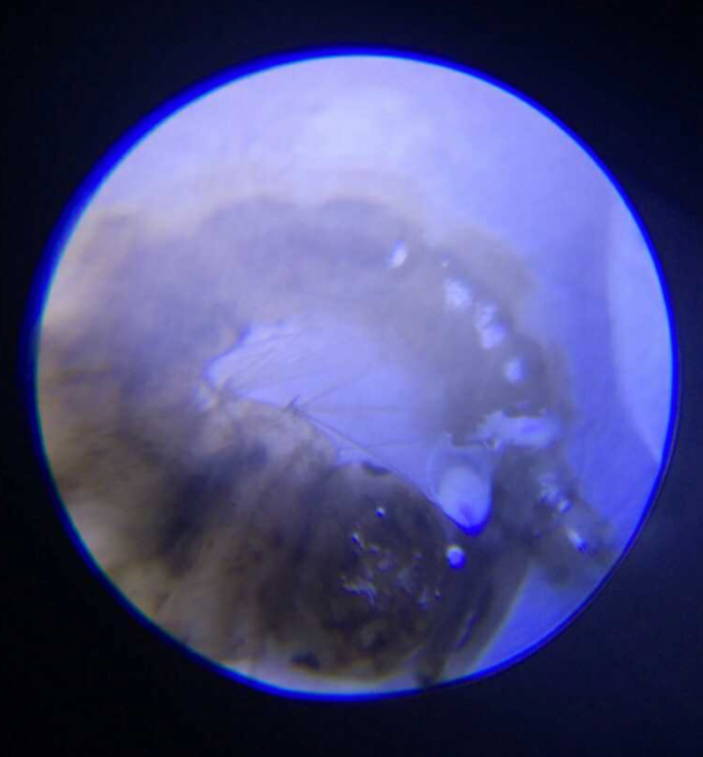 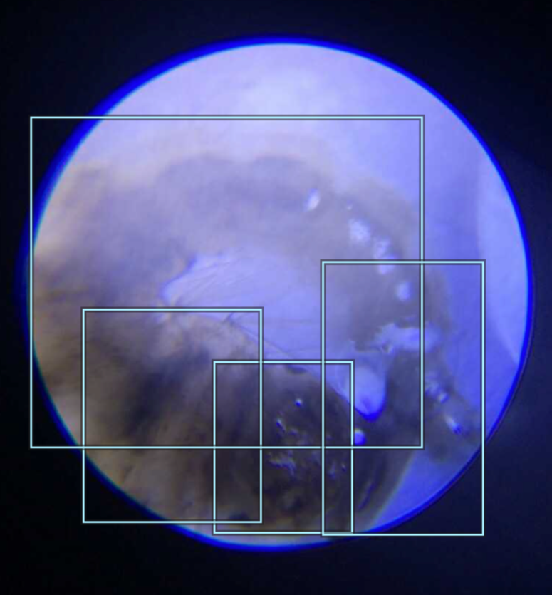

Challenge - for these types of blurred images, mostly where the larvae is placed in round shape, it’s hard to take the hair components on the box

Original Image Suggested boxes

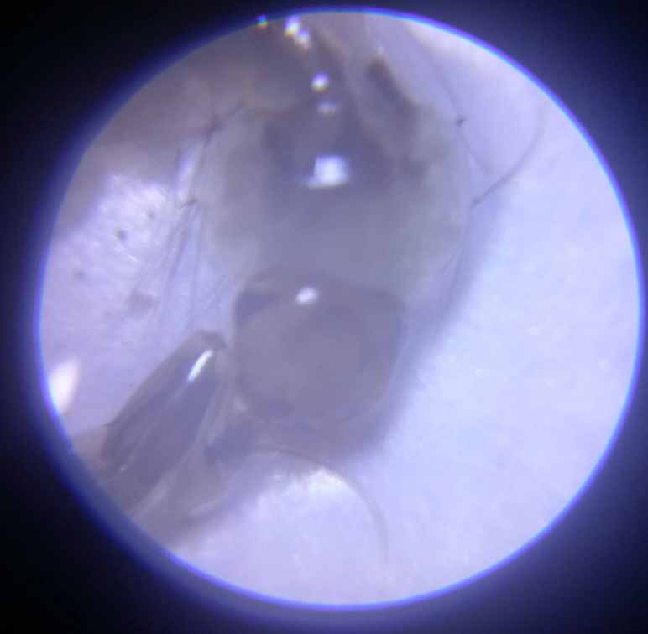 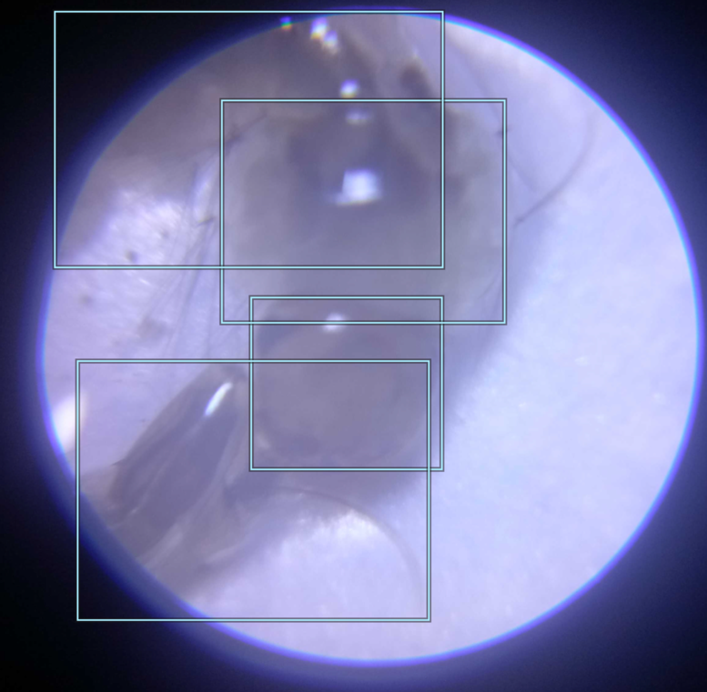

Challenge - For these types of images, it’s difficult to distinguish the which hair component belongs to abdomen or thorax, they all are mixed up

Original Image Suggested boxes

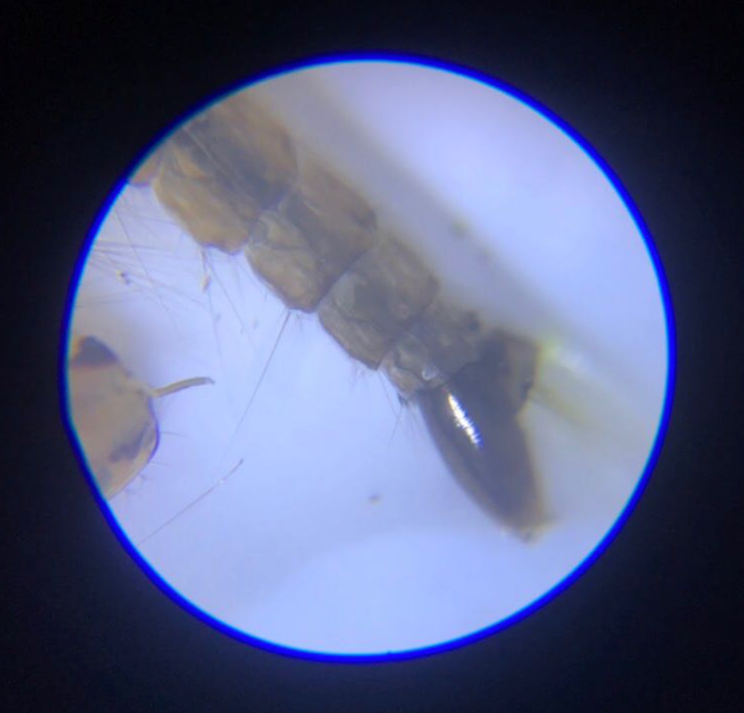 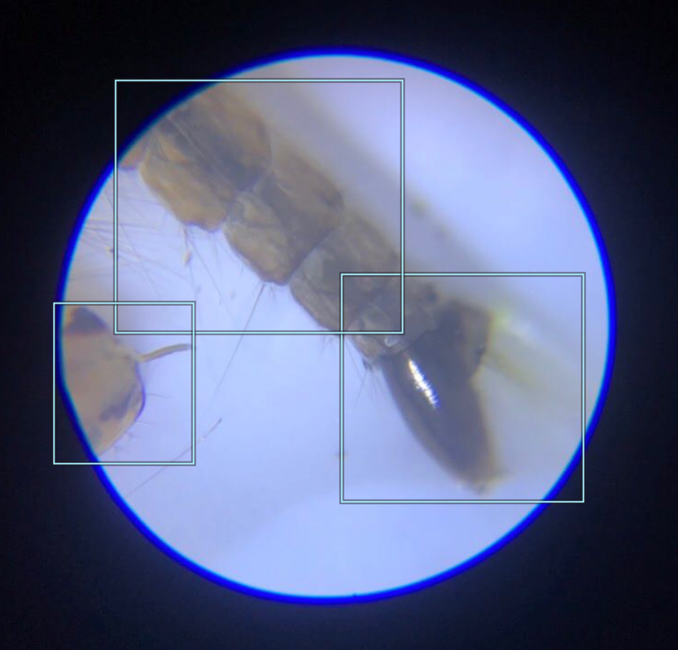



Challenge - Sometimes, there are some hairs (red marked) which can’t be determined because of the wrong position of the capture. It’s better to avoid those hairs.

Original Image Suggested boxes

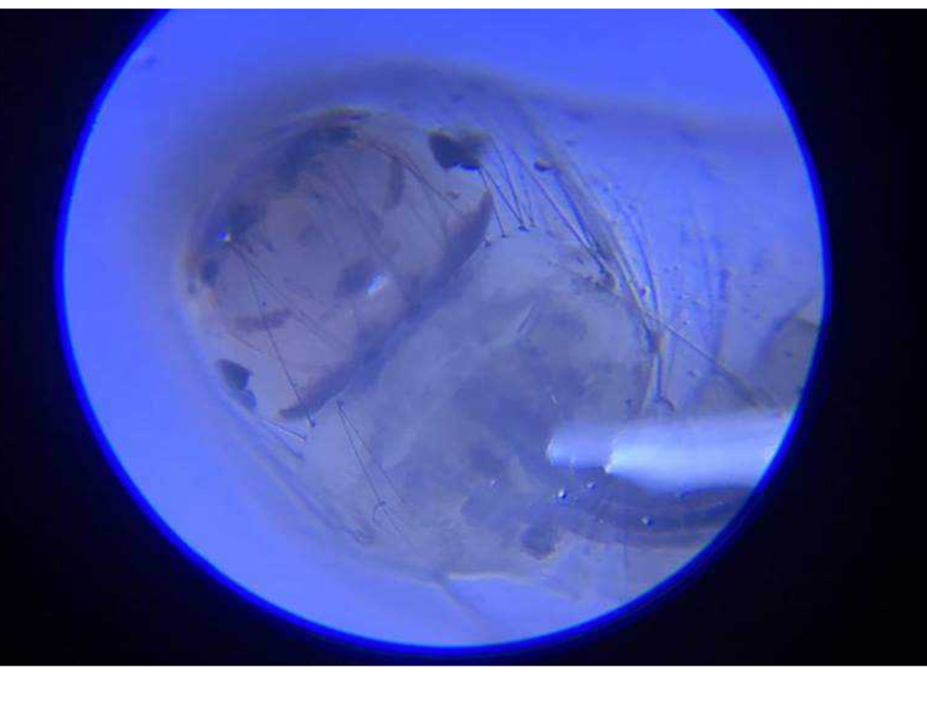 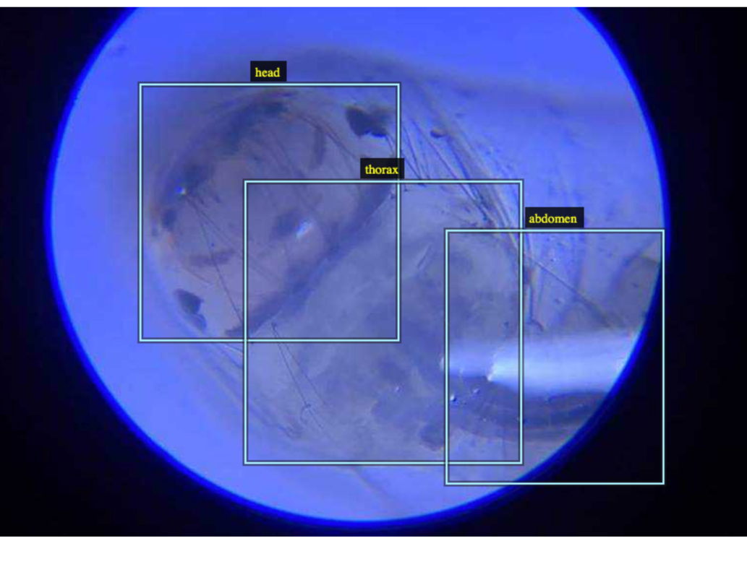

Challenge - For these type of images, there are lots of hair components and also some dirts (black dots) which make it difficult to box them.